Netherlands vs Japan Tickets: Japans Mitoma looks to regain strength give Brighton momentum ahead of FIFA 2026
Netherlands vs Japan Tickets: Japan football winger Kaoru Mitoma made his long-awaited return for Brighton, but says full fitness remains a work in progress ahead of the FIFA World Cup cycle. Japan football winger Kaoru Mitoma lately returned to competitive action for Brighton after a long injury absence.
We are offering FIFA World Cup 2026 Tickets. Football admirers can get Netherlands vs Japan Tickets through our trusted online ticketing marketplace. worldwideticketsandhospitality.com is the most reliable source for booking Football World Cup 2026 Tickets. Sign up for the latest Ticket alert. Don’t miss out on the chance to be at the heart of football history. Grab your tickets now and be there for the ultimate showdown!
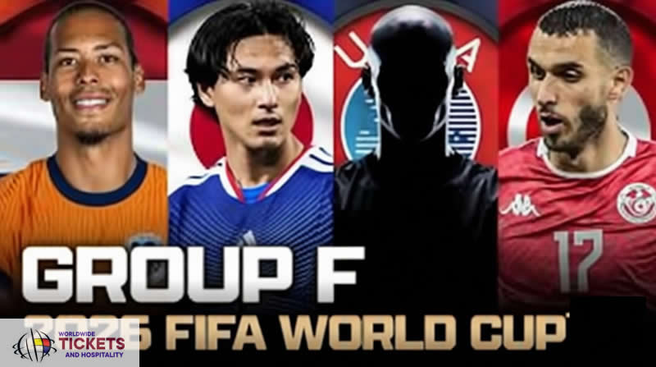
Still, his comeback came with mixed feelings. While he was pleased to be back on the pitch, he openly conceded that his performance was still short of expectations. This honesty reflects the mindset of a player concentrated on long-term success rather than short-term praise.
Mitoma entered the match during the second half against Liverpool at Anfield. This appearance marked his first football spin since suffering an ankle injury late in September. Although Brighton was formerly, his sharp movement showed signs of recovery. Still, he felt his overall influence remained limited.
Importantly, this return comes during a pivotal FIFA timeline. With World Cup medications still erecting, Mitoma knows every match matters. Thus, his gradational reintegration into club football is being handled with care. This approach allows him to recapture meter without gratuitous threat.

FIFA World Cup Tickets: Premier League Football Performance Shows Progress and Limits
During his substitute appearance, Mitoma displayed encouraging football traits. He pushed forward with purpose and tracked back diligently. These conduct stressed his work ethic and political mindfulness. Still, he also acknowledged that fitness situations affected his capability to change the game’s direction.
Experience football history live! Secure your FIFA World Cup Tickets with confidence at worldwideticketsandhospitality.com. From group stage matches to the thrilling FIFA World Cup Final, our platform offers a seamless booking experience and access to the best seats. Don’t miss your chance to witness the world’s greatest football moments. Book your dream match today.
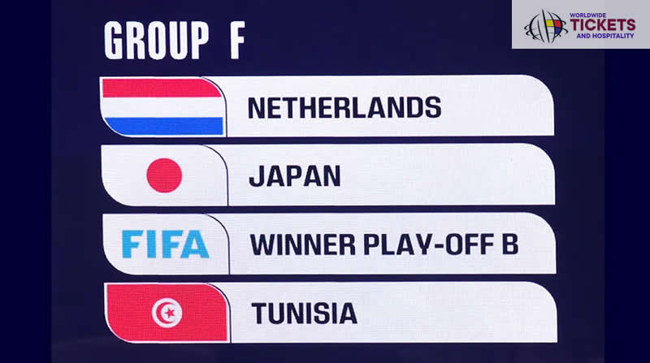
The winger admitted that his body isn't yet completely responsive. As a result, certain explosive movements and sustained pressure were missing. This assessment aligns with what numerous returning players experience after extended recuperation. Thus, tolerance remains essential.
From a football perspective, Brighton benefits from his presence indeed in limited twinkles. His positioning draws protectors and opens space. Still, Mitoma believes donation must go beyond presence alone. He wants to deliver decisive conduct. This mindset underlines his determination to return stronger.

Tunisia Vs Netherlands Tickets: Brighton Football Recovery Took Longer Than Planned
Brighton had originally hoped for a brisk football recovery after Mitoma’s injury. Beforehand, sanguinity suggested a hasty return. Still, the recuperation process needed further time than anticipated. The winger latterly explained that despite stylish sweats, progress couldn't be rushed.
Football World Cup enthusiasts around the globe can now secure their Tunisia Vs Netherlands Tickets through our online platform, worldwideticketsandhospitality.com. With a user-friendly interface and exclusive deals, fans can easily book tickets for exciting matches at discounted prices. Don't miss your chance to witness the world's greatest football event live! Visit FIFA World Cup 2026 Tickets today.
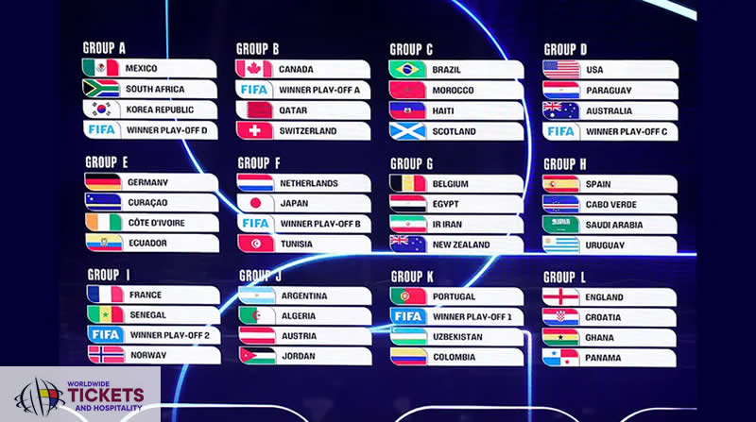
Injuries involving the ankle demand caution. For a footballer reliant on balance and acceleration, returning too early carries a threat. Thus, the extended recovery may eventually cover his long-term performance. Brighton’s medical staff covered each phase nearly.
This careful operation reflects Brighton’s broader football gospel. Player wealth takes precedence over immediate results. As a result, Mitoma returned only when he could train completely. While not perfect yet, he's now erecting match fitness steadily.
Don’t miss your chance to witness football history live! At worldwideticketsandhospitality.com, you can buy FIFA World Cup Final Tickets with complete confidence. We offer a secure and seamless booking experience, ensuring you get the best seats for the most anticipated match of the tournament. Explore our listings and reserve your place at the World Cup 2026 Final today!

Football World Cup Tickets: Japan Football Focus Remains Club First Before FIFA Stage
Mitoma’s injury absence overlapped with transnational football windows in October and November. Accordingly, he missed recent Japan public platoon friendlies. While this was disappointing, the winger accepted the situation calmly. His focus stayed on recovery rather than frustration.
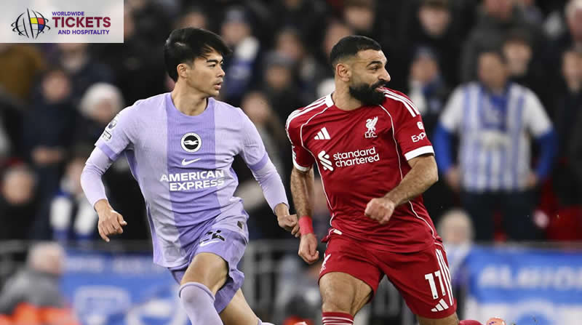
Looking ahead, the FIFA World Cup in twenty twenty six is approaching steadily. Despite this, Mitoma has made it clear that club football comes first. Helping Brighton in forthcoming matches remains his immediate priority. This approach allows him to recapture form naturally.
By concentrating on diurnal enhancement, Mitoma believes transnational readiness will follow. For Japanese football sympathizers, this steady path offers consolation. A completely fit and confident winger will be far more precious on the FIFA stage than a rushed return.
For fans eager to be part of the Football World Cup 2026 action, a wide range of official and premium ticket options is available at worldwideticketsandhospitality.com. Our platform partners exclusively with trusted sellers in the secondary market, ensuring you have access to the most reliable and high-quality ticket listings. Explore our extensive selection of Football World Cup 2026 Tickets today and secure the best deals for an unforgettable football experience!

FAQs

1. Why is Kaoru Mitoma not completely satisfied after his return?
He believes his fitness and influence are still below his usual football norms after injury recovery.

2. How long was Mitoma absent from football action?
He was sidelined for around two and a half months due to an ankle injury.

3. Which match did he make his return for Brighton?
His comeback came during a Premier League football match against Liverpool at Anfield.

4. Did the injury affect his Japan football appearances?
Yes, it averted him from joining recent public platoon friendlies during transnational windows.
5. How can I get the best seats for FIFA World Cup 2026 matches?
Fans can secure the best seats through worldwideticketsandhospitality.com, which offers a seamless booking experience and access to official ticket listings for all World Cup matches.

