Ivory Coast Vs Ecuador Tickets: Ivory Coast Embrace Group Of Death As Fae Backs Squad For FIFA 2026 Push
Ivory Coast vs Ecuador Tickets: Ivory Coast prepares for a demanding AFCON crusade with trainer Fae standing firm on his team selection as the team enters a grueling group. Ivory Coast head into the forthcoming AFCON event knowing that the group stage will test every part of their preparation.
We are offering FIFA World Cup 2026 Tickets. Football admirers can get Ivory Coast vs Ecuador Tickets through our trusted online ticketing marketplace. worldwideticketsandhospitality.com is the most reliable source for booking Football World Cup 2026 Tickets. Sign up for the latest Ticket alert. Don’t miss out on the chance to be at the heart of football history. Grab your tickets now and be there for the ultimate showdown!

The draw has placed the defending titleholders alongside opponents with strong international birth and differing styles. For the mammoths, this means there's little periphery for error from the opening match. The group is extensively viewed as the most competitive in the event due to the balance of power and experience among all brigades involved.
Each side has realistic intentions of reaching the knockout phase, which raises the intensity of every institution. Ivory Coast must thus approach the group with both political discipline and attacking confidence. Preparation has focused on maintaining the identity that led to recent success while adapting to new challenges.
Training camps have emphasized physical sharpness and internal adaptability. The guiding staff believes that facing top opponents beforehand can edge focus and concinnity within the team. Sympathizers in the Ivory Coast see the group as a true measure of the platoon's progress. While the task is delicate. There's also excitement about high-quality.
Matches that could define the event. Success in such a group would confirm the mammoth's status among African nobility.

FIFA World Cup Tickets: Coach Fae Defends Squad Selection Strategy
Coach Emerse Fae has addressed debate, girding his team choices with calm assurance. Some spectators questioned the addition of certain players and the omission of others who have impressed at club positions. Fae's response has centered on balance, chemistry, and political felicity rather than character alone.
Experience football history live! Secure your FIFA World Cup Tickets with confidence at worldwideticketsandhospitality.com. From group stage matches to the thrilling FIFA World Cup Final, our platform offers a seamless booking experience and access to the best seats. Don’t miss your chance to witness the world’s greatest football moments. Book your dream match today.

According to the trainer, the team reflects a mix of experience and arising gift able of handling pressure. He stressed that transnational events bear players who understand places and can acclimate quickly. Training performances and station were crucial factors in the final opinions.
Fae also stressed the significance of durability following recent success. Retaining a core group allows the platoon to make on established patterns of play. This approach is seen as vital when facing strong opponents in a tight group where cohesion can decide results.
The trainer's communication has been clear that every named player earned their place. He prompted suckers to trust the process and support the platoon inclusively. By standing firm, Fae aims to produce a focused terrain free from distraction as the event approaches.

Germany vs Ivory Coast Tickets: Tactical Challenges Await the mammoths
Ivory Coast politic approach will be tested by the variety of opponents in the group. Each rival presents different pitfalls, from physical strength to specialized control. Preparing for similar diversity requires inflexibility in conformation and game operation. The mammoths are anticipated to rely on a solid protective structure supported by quick transitions.
Football World Cup enthusiasts around the globe can now secure their Germany vs Ivory Coast Tickets through our online platform, worldwideticketsandhospitality.com. With a user-friendly interface and exclusive deals, fans can easily book tickets for exciting matches at discounted prices. Don't miss your chance to witness the world's greatest football event live! Visit FIFA World Cup 2026 Tickets today.
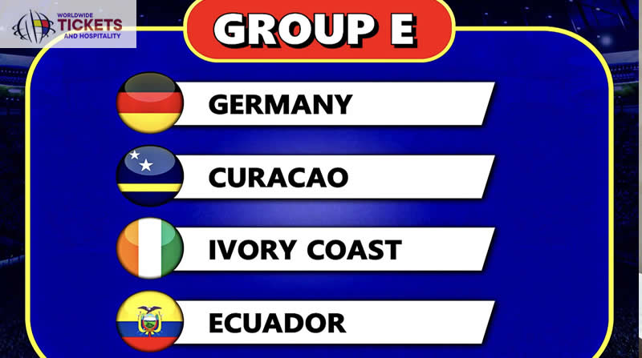
Midfield control will be pivotal in limiting opposition influence while creating chances for the forwards. The guiding staff have worked on scripts that may arise during tight matches. Set pieces are another area of focus given their significance in event football. Small details can swing games in unevenly matched groups.
Ivory Coast needs to be effective in both defending and attacking dead-ball situations. Mental strength will be just as important as tactics. Playing high-pressure matches in quick races demands attention and recovery. The platoon leadership group is assigned with keeping norms high and icing belief remains strong anyhow of early results.
Don’t miss your chance to witness football history live! At worldwideticketsandhospitality.com, you can buy FIFA World Cup Final Tickets with complete confidence. We offer a secure and seamless booking experience, ensuring you get the best seats for the most anticipated match of the tournament. Explore our listings and reserve your place at the World Cup 2026 Final today!

Football World Cup Tickets: Prospects and Belief Within the Squad
Despite the difficulty of the group, there's a strong belief within the Ivory Coast camp. Players have spoken about embracing the challenge rather than stewing over it. Confidence comes from recent achievements and the depth available across the team. The atmosphere around the platoon suggests a united group apprehensive of the responsibility they carry.

Representing the Ivory Coast on the international stage brings pride and anticipation. The players are motivated to show thickness and maturity. Suckers will play a significant part indeed from hence. Support has been described as a driving force that lifts performance during tough moments.
The team understands the emotional connection and aims to award fidelity with married displays. Eventually, the group of death markers is seen as an occasion. Success against strong opponents can make instigation for after stages. Ivory Coast entered the event determined to prove that their status is merited through performance on the pitch.
For fans eager to be part of the Football World Cup 2026 action, a wide range of official and premium tickets options is available at worldwideticketsandhospitality.com. Our platform partners exclusively with trusted sellers in the secondary market, ensuring you have access to the most reliable and high-quality ticket listings. Explore our extensive selection of Football World Cup 2026 Tickets today and secure the best deals for an unforgettable football experience!

FAQs

1. Why is the Ivory Coast group considered the toughest at AFCON?
The group includes brigades with strong records and balanced outfits, which makes every match competitive and changeable.

2. What has trainer Fae said about the review of his team's picks?
He has emphasized balance, chemistry, and political fit while stating that all named players earned their place.

3. How is the Ivory Coast preparing for different opponents?
Training has concentrated on physical inflexibility, physical readiness, and internal adaptability to handle varied playing styles.

4. What will be crucial to the Ivory Coasts success in the group?
Strong platoon cohesion, protective discipline, and effective use of chances are anticipated to be decisive factors.
5. How can I get the best seats for FIFA World Cup 2026 matches?
Fans can secure the best seats through worldwideticketsandhospitality.com, which offers a seamless booking experience and access to official ticket listings for all World Cup matches.

