Scotland vs Brazil Tickets: Miamis Final Match Schedule For The FIFA World Cup 2026 Now Available
Scotland vs Brazil Tickets: Scotland vs Brazil emerges as a high-interest FIFA concentrated tourney as the Miami final match scheduling for the World Cup 2026 earns clarity. The FIFA World Cup 2026 has entered a planning phase that excites suckers across the mainland. Thus, attention has shifted toward implicit show matches.
We are offering FIFA World Cup 2026 Tickets. Football admirers can get Scotland vs Brazil Tickets through our trusted online ticketing marketplace. worldwideticketsandhospitality.com is the most reliable source for booking Football World Cup 2026 Tickets. Sign up for the latest Ticket alert. Don’t miss out on the chance to be at the heart of football history. Grab your tickets now and be there for the ultimate showdown!

Scotland vs Brazil stands out because it reflects tradition and ambition within FIFA competition. Also, Miami has verified its role as a crucial host megacity. As a result, conversations around final match scheduling have increased. Scotland brings a disciplined style shaped by European events. Meanwhile, Brazil carries a heritage built on creativity and titles.
Accordingly, this discrepancy fits the FIFA vision of global football concinnity. In addition suckers view this tourney as a symbol of competitive balance. Therefore, the scheduling news resonates explosively. Likewise, Miami offers a world-class stage for FIFA events.
Its structure supports major transnational crowds. Thus, any match involving Scotland vs Brazil earns added prestige. In short, the environment of the FIFA World Cup 2026 planning elevates this pairing beyond enterprise. It becomes a focal point of expectation.

FIFA World Cup Tickets: Significance of Scotland on the World Stage
Scotland's participation in the FIFA World Cup 2026 represents continuity and growth. Historically, the platoon has shown adaptability. Thus, each appearance carries meaning. Against Brazil, the challenge becomes indeed less. Yet this challenge aligns with FIFA's values of fair competition. Scotland politic structure emphasizes cooperation.
Experience football history live! Secure your FIFA World Cup Tickets with confidence at worldwideticketsandhospitality.com. From group stage matches to the thrilling FIFA World Cup Final. Our platform offers a seamless booking experience and access to the best seats. Don’t miss your chance to witness the world’s greatest football moments. Book your dream match today.
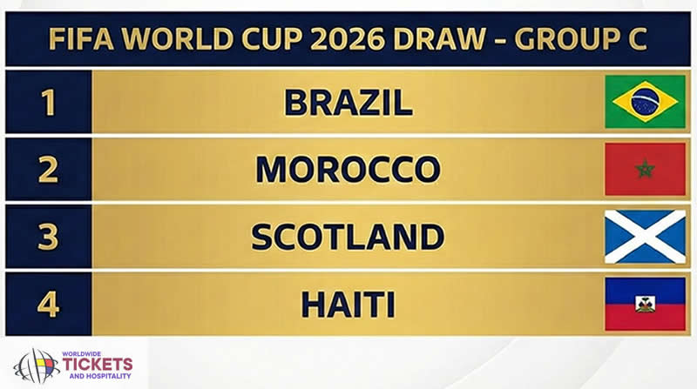
As a result, matches frequently remain violent. Also facing protective discipline. Accordingly, suckers anticipate a strategic contest. FIFA events thrive on a similar balance. Hence, Scotland part shouldn't be undervalued. In addition, FIFA scheduling in Miami highlights inclusivity. Scotland sympathizers across North America gain access.
Thus, engagement expands. This supports FIFA's pretensions for global reach. Also, the exposure helps develop unborn gifts. In summary, Scotland's presence within FIFA World Cup 2026 planning adds depth and narrative strength.

Brazil Vs Morocco Tickets: FIFA Legacy and Brazils Influence in the event
Brazil's influence within FIFA competitions remains unmatched. The platoon symbolizes faculty and success. Thus, any match involving Brazil draws worldwide interest. Scotland vs Brazil particularly showcases the discrepancy. As a result, FIFA benefits from heightened visibility.
We are offering FIFA World Cup 2026 Tickets. Football admirers can get Brazil Vs Morocco Tickets through our trusted online ticketing marketplace. worldwideticketsandhospitality.com is the most reliable source for booking Football World Cup 2026 Tickets. Sign up for the latest Ticket alert. Don’t miss out on the chance to be at the heart of football history. Grab your tickets now and be there for the ultimate showdown!

Brazil's attacking style entertains suckers. Meanwhile, FIFA aims to celebrate different football societies. Therefore, Brazil fits impeccably into Miami-hosted matches. Also, the scheduling advertisement amplifies excitement. Accordingly, conversations concentrate on implicit high-profile hassles.
Also, Brazil's experience in test sets prospects. Scotland faces pressure but also occasions. Thus, this tourney aligns with FIFA's liar. It highlights the spirit versus dominance. In conclusion, Brazil's participation reinforces the prestige of the FIFA World Cup 2026 and its Miami stage.
Don’t miss your chance to witness football history live! At worldwideticketsandhospitality.com, you can buy FIFA World Cup Final Tickets with complete confidence. We offer a secure and seamless booking experience, ensuring you get the best seats for the most anticipated match of the tournament. Explore our listings and reserve your place at the World Cup 2026 Final today!

Football World Cup 2026 Tickets: FIFA Scheduling Impact and Fan Prospects
Scotland vs Brazil Tickets: FIFA's evidence of Miami final match scheduling influences addiction planning. Thus trip and engagement increase. Scotland vs Brazil becomes a talking point within this frame. As a result, sympathizers prepare beforehand. Scotland vs Brazil Draws Global Attention as FIFA Match Planning Takes Shape in Miami.

Likewise, FIFA scheduling translucency builds trust. Suckers appreciate clarity. Accordingly, excitement grows steadily. Miami's position also adds artistic appeal. Therefore, FIFA strengthens its global image.
Also, this tourney sparks media content. Thus, expectation spreads beyond traditional cult. Scotland and Brazil suckers likewise engage online. In summary, FIFA scheduling opinions enhance the significance of Scotland vs Brazil while buttressing World Cup 2026 instigation.
For fans eager to be part of the Football World Cup 2026 action, a wide range of official and premium ticket options is available at worldwideticketsandhospitality.com. Our platform partners exclusively with trusted sellers in the secondary market, ensuring you have access to the most reliable and high-quality ticket listings. Explore our extensive selection of Football World Cup 2026 Tickets today and secure the best deals for an unforgettable football experience!

1. Why is Scotland vs Brazil important in FIFA World Cup 2026 conversations
This tourney highlights the discrepancy and tradition that FIFA values in global events.

2. How does Miami's hosting affect FIFA planning?
Miami provides structure and global appeal that support major FIFA matches.

3. What does this mean for Scotland within FIFA?
It increases exposure and tests Scotland's growth on a major FIFA stage.

4. Why does Brazil attract attention in FIFA events?
Brazil's heritage and style constantly elevate interest and viewership in FIFA events.
5. How can I get the best seats for FIFA World Cup 2026 matches?
Fans can secure the best seats through worldwideticketsandhospitality.com, which offers a seamless booking experience and access to official ticket listings for all World Cup matches.

