Portugal Vs Uzbekistan Tickets: Martinez Explains What Ronaldo Brings To Portugal National Team
Portugal Vs Uzbekistan Tickets: Portugal's public team manager, Roberto Martinez, explains the FIFA impact of Cristiano Ronaldo on leadership identity and performance for the public side. Roberto Martinez has spoken about the strong FIFA influence Cristiano Ronaldo brings to the Portuguese national team. According to the trainer, Ronaldo sets the standard every day.
We are offering FIFA World Cup 2026 Tickets. Football admirers can get Portugal Vs Uzbekistan Tickets through our trusted online ticketing marketplace. worldwideticketsandhospitality.com is the most reliable source for booking Football World Cup 2026 Tickets. Sign up for the latest Ticket alert. Don’t miss out on the chance to be at the heart of football history. Grab your tickets now and be there for the ultimate showdown!
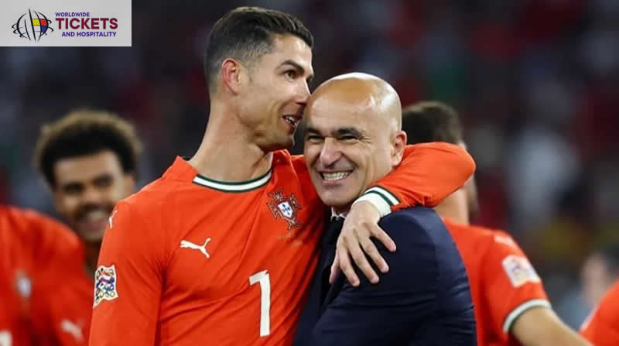
His station in training raises focus. His presence shapes discipline. Young players watch and learn fast. Also, Martinez believes Ronaldo brings clarity in pressure moments. Big events demand calm minds. Ronaldo has lived those moments frequently. Thus, his experience helps the platoon stay composed.
This matters in FIFA competitions where perimeters are tight. In addition, Ronaldo connects generations inside the team. Elderly players trust him. New faces feel guided. As a result, the group stays united. Martinez sees this concinnity as a base for harmonious FIFA results.
Eventually, leadership isn't only about words. Ronaldo shows it through habits. Work rate stays high. Provocation spreads naturally. For Martinez, this influence remains vital for Portugal's public platoon intentions under FIFA fabrics.

FIFA World Cup Tickets: FIFA Tactical Importance of Ronaldo in Modern Portugal Setup
Martinez also explained the FIFA political value Ronaldo adds to the Portuguese public platoon. Indeed, as the game evolves, Ronaldo adapts. He understands space better now. His movement opens lanes for teammates. This supports a fluid attacking shape. Likewise, Ronaldo attracts protective attention.
Experience football history live! Secure your FIFA World Cup Tickets with confidence at worldwideticketsandhospitality.com. From group stage matches to the thrilling FIFA World Cup Final. Our platform offers a seamless booking experience and access to the best seats. Don’t miss your chance to witness the world’s greatest football moments. Book your dream match today.
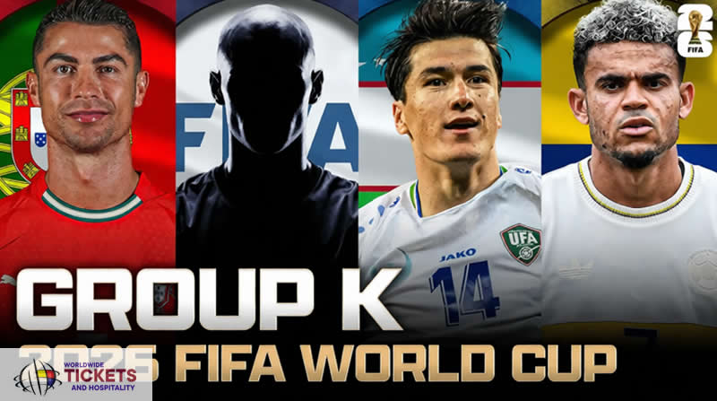
Opponents acclimate their lines. This creates gaps. Midfield players gain time. Wingers find freedom. Martinez uses this effect in FIFA match plans. In addition, Ronaldo offers trustworthiness in the box. Portugal produces numerous chances. Finishing still matters most. Ronaldo converts pressure into pretensions.
This remains pivotal during FIFA qualifiers and events. Incipiently, Martinez values Ronaldo's game intelligence. He reads tempo well. He knows when to drop deep. He knows when to stay high. This balance helps the platoon control matches. Thus, his political party stays applicable in FIFA football.

Colombia Vs Portugal Tickets: FIFA Mental Strength and Competitive Drive Within the Squad
Another crucial point from Martinez is the FIFA internal edge Ronaldo provides. Competitive drive defines elite brigades. Ronaldo carries this drive daily. Training intensity rises. Norms stay high. Complacency disappears. Also, pressure frequently affects youngish players. FIFA events test jitters.
Football World Cup enthusiasts around the globe can now secure their Colombia Vs Portugal Tickets through our online platform, worldwideticketsandhospitality.com. With a user-friendly interface and exclusive deals, fans can easily book tickets for exciting matches at discounted prices. Don't miss your chance to witness the world's greatest football event live! Visit FIFA World Cup 2026 Tickets today.
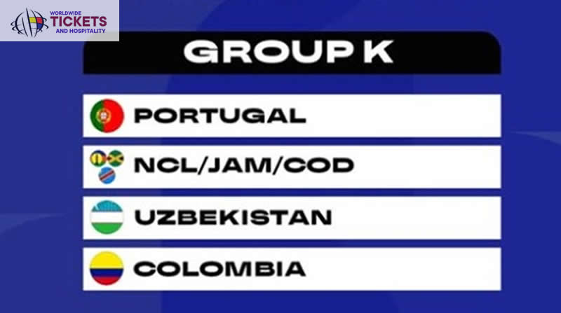
Ronaldo's presence calms them. His confidence becomes contagious. Players believe further. They take responsibility. This strengthens the group's intelligence. Moreover, lapses occur in football. Missed chances do. Conceded pretensions hurt. Ronaldo reacts snappily. He demands a response. Martinez sees this response as essential in FIFA matches.
Eventually, winning habits matter. Ronaldo brings a culture of winning. He prepares strictly. Recovery routines stay strict. Nutrition and concentration matter. This professionalism lifts the whole Portuguese public platoon under FIFA competition demands.
Don’t miss your chance to witness football history live! At worldwideticketsandhospitality.com, you can buy FIFA World Cup Final Tickets with complete confidence. We offer a secure and seamless booking experience, ensuring you get the best seats for the most anticipated match of the tournament. Explore our listings and reserve your place at the World Cup 2026 Final today!

Football World Cup Tickets: FIFA Vision of Martinez for Ronaldos Role Going Forward
Martinez participated in his FIFA vision for Ronaldo's unborn child. Age doesn't reduce influence. Places may evolve. Donation remains strong. Martinez focuses on balance. He blends youth with experience. In this vision, Ronaldo supports arising gift. He instructs naturally. Advice comes through action.
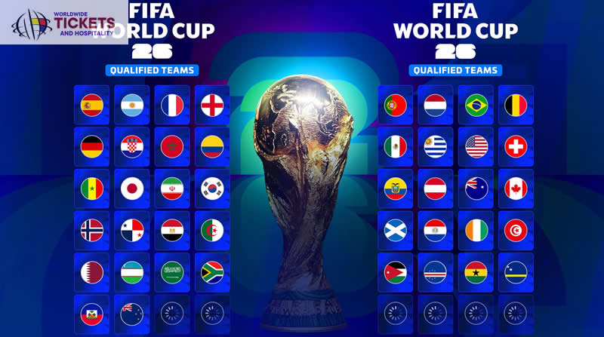
This accelerates growth. Portugal benefit long term in FIFA cycles. Also, gyration becomes strategic. Martinez manages twinkles precisely. Fitness stays optimal. Impact remains high. This approach protects Ronaldo's effectiveness across FIFA juggernauts.
Eventually, Martinez sees Ronaldo as a pillar. Not just for pretensions. For identity. For belief. For direction. Under FIFA competition structures, this part keeps Portugal's public platoon competitive and ambitious.
For fans eager to be part of the Football World Cup 2026 action, a wide range of official and premium ticket options is available at worldwideticketsandhospitality.com. Our platform partners exclusively with trusted sellers in the secondary market, ensuring you have access to the most reliable and high-quality ticket listings. Explore our extensive selection of Football World Cup 2026 Tickets today and secure the best deals for an unforgettable football experience!

FAQs

1. Why does Martinez value Ronaldo's leadership in FIFA events?
Martinez values leadership because it raises norms and keeps the team concentrated during high-pressure FIFA matches.

2. How does Ronaldo help youngish Portugal players?
Ronaldo guides them through illustration by showing discipline, work heritage, and calm gestures
in FIFA events.

3. Is Ronaldo still tactically important for Portugal?
Yes, his movement and attention from protectors produce space, which supports the platoon structure in FIFA games.

4. Does Martinez plan to reduce Ronaldo's part?
No, Martinez plans to manage his part wisely to keep the impact strong through long FIFA schedules.
5. How can I get the best seats for FIFA World Cup 2026 matches?
Fans can secure the best seats through worldwideticketsandhospitality.com, which offers a seamless booking experience and access to official ticket listings for all World Cup matches.

