Where to Buy High-Quality Power Tools Online With Fast Shipping in Dubai
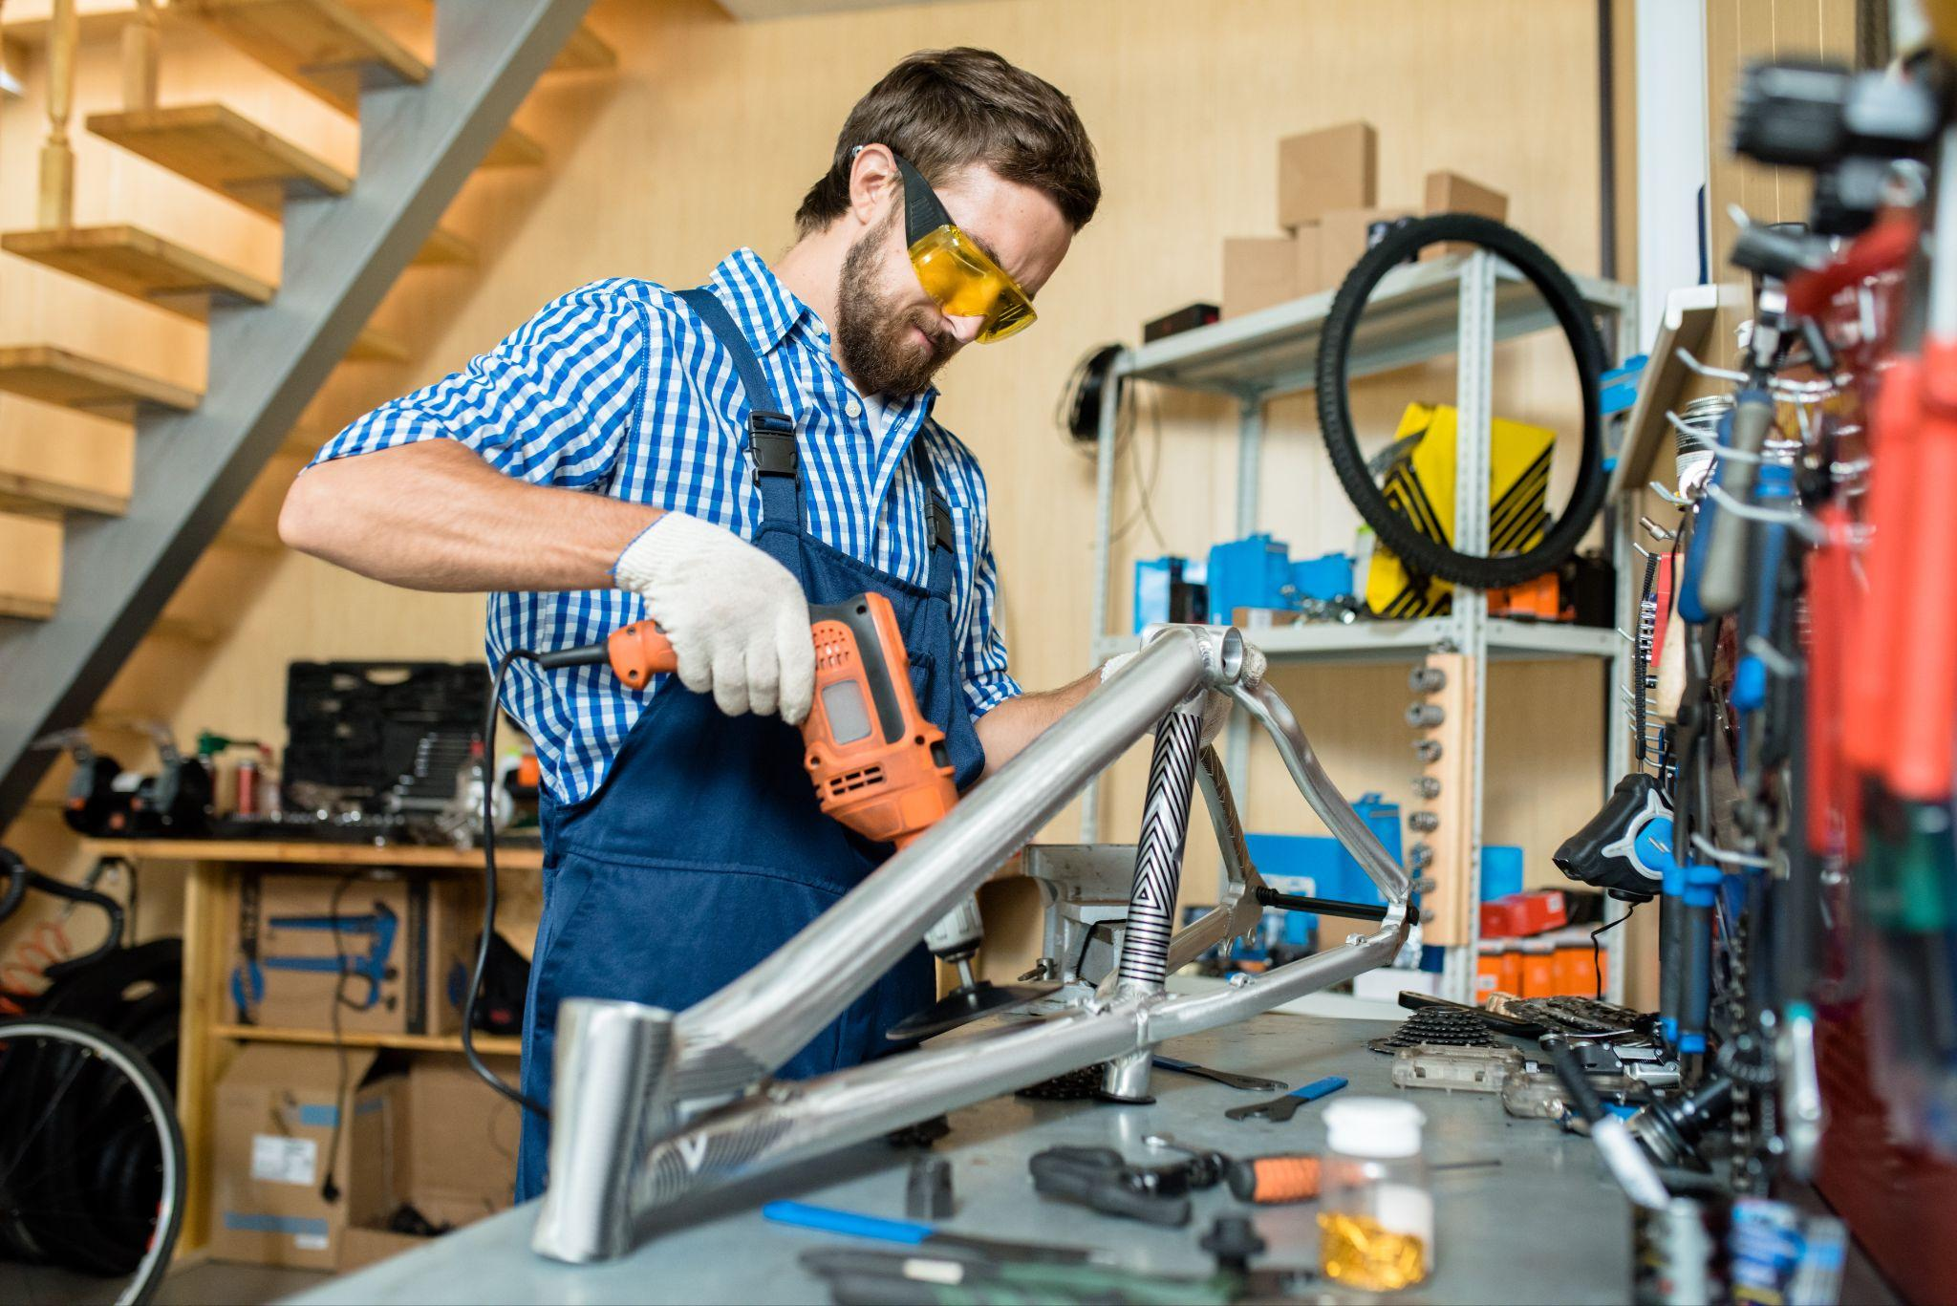
Finding high-quality power tools in Dubai has become essential for construction teams, MEP contractors, fabrication workshops, and professionals who cannot afford delays. Whether you’re working on a construction site or handling daily maintenance tasks, you need power tools that are reliable, original, and delivered quickly.
But with so many online platforms and suppliers, the big question is:
Where can you buy trusted, durable power tools online with fast shipping in Dubai?
This guide helps you choose the right place and explains why a long-established supplier like Damam Hardware is a dependable choice for professionals across the UAE.

Why Online Buying of Power Tools Is Growing in Dubai
Dubai's fast-growing projects require tools that are ready to use without waiting days for delivery. Online buying is increasing because it offers:
- Easy ordering from job sites
- Quick access to different tool categories
- Fast delivery across Dubai
- Clear product specifications
- Convenience for busy project schedules
However, not every online supplier provides genuine products or professional-level support. That’s why choosing the right supplier matters more than ever.

The Importance of Choosing a Trusted Power Tool Supplier
Power tools are long-term investments. A wrong purchase affects:
- Project timelines
- Site productivity
- Safety
- Maintenance cost
This is why professionals prefer suppliers who have:
- A strong market reputation
- A wide range of genuine, brand-backed tools
- Knowledge of construction and industrial requirements
- Fast and reliable delivery services
- Proper warranty support

Where to Buy High-Quality Power Tools Online With Fast Shipping in Dubai
Below are the key reasons why Damam Hardware stands out as a reliable online source for power tools in Dubai:

1. Genuine, High-Quality Power Tools From Reputable Manufacturers
When professionals shop online, the biggest concern is product authenticity.It ensures that every tool we supply is sourced directly from reputable global manufacturers.
This means customers get:
- Original quality
- Reliable performance
- International standards
- Warranty-backed products
Whether you need drills, grinders, cutters, saws, or other essential power tools, authenticity is never a question.

2. Fast Shipping Across Dubai
In construction and industrial environments, delays can affect entire project timelines. It supports fast delivery due to:
- A well-organized logistics center
- Efficient order-processing
- Strong inventory availability
This ensures that your power tools reach you quickly—whether you are in a workshop, a site office, or a high-rise project location. Fast shipping is a major reason why customers prefer buying from trusted UAE-based suppliers instead of international marketplaces.

3. Wide Range of Tools for Professional Use
A good supplier must offer tools that match the needs of different industries.Professionals can browse a wide variety of power tools suitable for:
- Construction
- MEP works
- Fabrication and maintenance
- Institutional operations
- Prefab manufacturing
Having multiple categories in one place helps customers save time and get everything from a single source.

4. Warranty Support and Technical Confidence
Every power tool must backed by:
- Manufacturer warranty
- Certified technical details
- Compliance with global specifications
This builds confidence for professionals who need tools that can withstand heavy-duty, daily use.

5. Easy Ordering and Customer Support
Buying online shouldn’t be confusing. Customers choose should provide:
- Clear product details
- Guidance on tool selection
- Industry-based recommendations
- Support for material and tool inquiries
This level of understanding comes from decades of supplying to construction, MEP, and fabrication companies across the UAE.

What to Check Before Buying Power Tools Online
To ensure a smooth buying experience, always check:

✔ Product authenticity

✔ Warranty availability

✔ Delivery time

✔ Clear specifications

✔ Supplier credibility
A trustworthy supplier makes all these factors simple and transparent.

Why Fast Shipping Is Critical in Dubai’s Work Environment
Fast-paced work culture in Dubai means teams must have tools ready when needed. Fast shipping helps:
- Maintain project deadlines
- Prevent downtime
- Keep sites running efficiently
- Support urgent project requirements
That’s why buyers prefer suppliers who understand industry timelines and deliver quickly.

Why Store Fits the Needs of Dubai Professionals
By combining experience, reputation, genuine products, and reliable delivery, Damam Hardware has become a dependable choice for anyone searching for:
“Where to buy high-quality power tools online with fast shipping in Dubai.”
Our long-standing presence since 1993, strong industry relationships, and commitment to quality keep us in line with the demands of modern construction and industrial environments.

For More Details Visit
Email: sales@damamhardware.com
Mobile : +971-56-422-7502
Web : https://www.damamhardware.com/
Address - Opposite Deyarco Furniture Factory,
New Industrial Area 2 – Ajman

