Best Deals on Cutting Tools from Trusted Suppliers in UAE
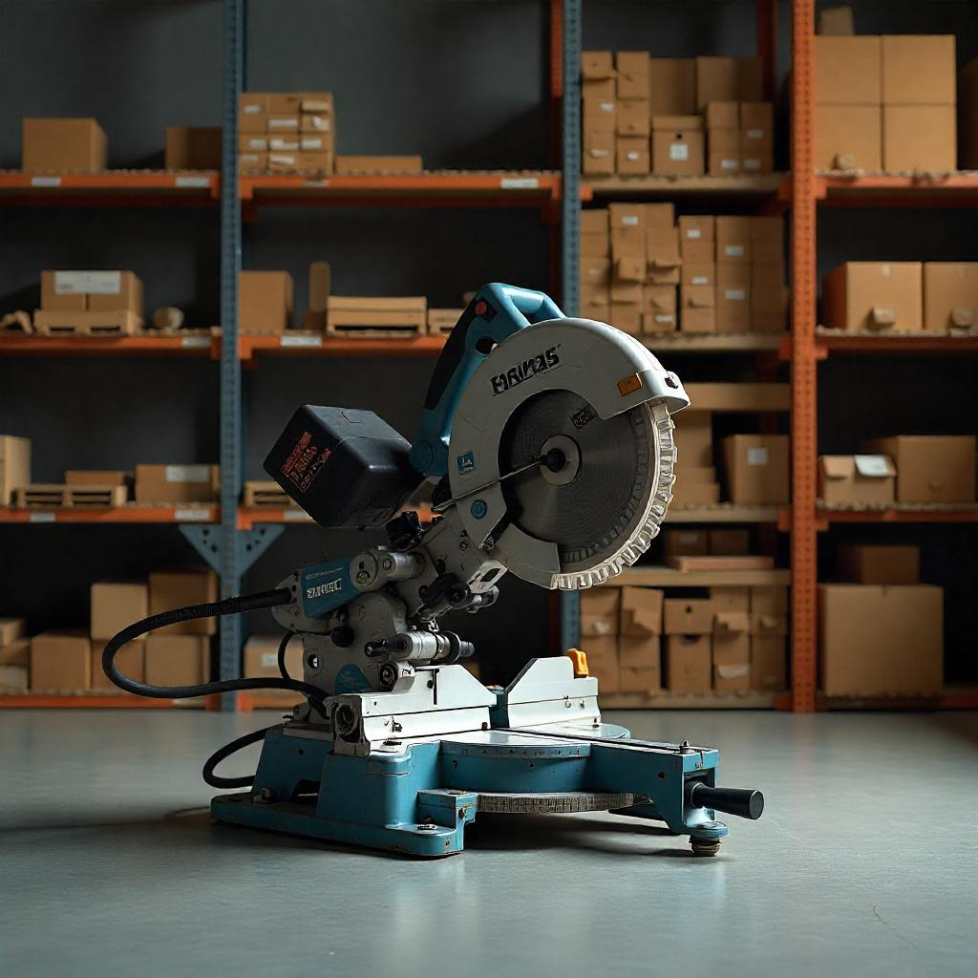

When it comes to maintaining precision and efficiency in industries such as manufacturing, construction, and metalworking, having access to top-quality cutting tools is essential. Whether you are a contractor, factory owner, or DIY enthusiast, choosing the right cutting tools suppliers in UAE can make all the difference in achieving optimal performance, durability, and cost-effectiveness for your projects.
This blog will guide you through the best deals available in the UAE, where to find trusted suppliers, and how investing in high-quality cutting tools can benefit your operations.

Why Quality Cutting Tools Matter
Cutting tools are the backbone of many industries. They are used in various applications, from precision machining and metal fabrication to woodworking and construction. Choosing the right tools ensures accuracy, minimizes downtime, and reduces the need for frequent replacements. When you opt for high-quality cutting tools, you are not only improving the efficiency of your projects but also ensuring longevity and a better finish.
The UAE is home to some of the best cutting tools suppliers, offering a wide range of products designed to meet the diverse needs of different industries. Here’s why you should prioritize quality when choosing your cutting tools:
- Precision: High-quality tools ensure that cuts are sharp and accurate, reducing errors.
- Durability: Professional-grade tools last longer, saving you money in the long term.
- Efficiency: With the right tools, tasks can be completed faster, improving productivity.

Top Cutting Tools Available in the UAE
The UAE market offers a vast selection of cutting tools for various applications. These tools are designed for different materials, ranging from metal and wood to plastics and composites. Here’s a quick overview of the most popular types:

1. End Mills
End mills are a popular type of cutting tool used for milling operations. These tools are perfect for making cuts in a variety of materials. From aluminum to steel, end mills can handle tough jobs and are available in different designs, including roughing, finishing, and slotting.

2. Drill Bits
Drill bits are indispensable for drilling holes into a variety of materials. With options like carbide drill bits and high-speed steel drill bits, they are ideal for creating precise holes in metals, wood, and plastics.

3. Saw Blades
For cutting larger materials such as metal sheets, wood, and plastic, saw blades are necessary. High-quality saw blades, such as diamond blades and circular saw blades, ensure smooth and accurate cuts with minimal wear.

4. Lathe Tools
Lathe tools are used for turning operations and can handle materials like metal, wood, and plastic. These tools are crucial for creating cylindrical shapes and performing operations such as cutting, drilling, and shaping.

5. Cutting Taps
Used primarily in the manufacturing industry, cutting taps are essential for creating internal threads in various materials. High-quality taps ensure clean threads, reducing the risk of errors and ensuring efficient production.

Benefits of Working with Trusted Cutting Tool Suppliers in UAE
Choosing the right cutting tools suppliers in UAE ensures that you receive premium products, reliable support, and competitive pricing. Here’s why working with trusted suppliers, like Saleh Ishaq Trading Co. L.L.C, can make a big difference:

a) Expert Guidance and Recommendations
Trusted suppliers offer expert advice on the best cutting tools for your specific needs. They will help you choose tools that align with the materials you work with, ensuring optimal performance and longevity.

b) Access to Top-Quality Products
Reputable suppliers only offer high-quality products from well-known manufacturers. This means you’ll be working with tools that meet international standards for precision and durability.

c) Competitive Pricing
When you buy from trusted cutting tools suppliers in UAE, you are not only guaranteed quality but also access to the best prices. These suppliers often offer bulk purchasing discounts and seasonal promotions, ensuring you get the best deals available in the market.

d) After-Sales Support and Services
Leading suppliers like Saleh Ishaq Trading Co. L.L.C offer comprehensive after-sales support, which includes tool maintenance, repairs, and replacement services. This added support ensures that your tools stay in top condition throughout their lifespan.

How to Choose the Right Cutting Tools Supplier
When selecting a supplier, you should consider several factors to ensure that you are getting the best value for your investment:

1. Reputation
Look for suppliers with a strong reputation in the market. Trusted companies are known for offering high-quality tools and excellent customer service. A supplier with positive reviews and testimonials is a good indicator of reliability.

2. Product Range
Make sure the supplier offers a wide variety of cutting tools to choose from. A comprehensive selection ensures you can find the exact tools you need for different projects and applications.

3. Customer Service
Excellent customer service is crucial when it comes to troubleshooting, returns, and support. Ensure that your supplier has a dedicated customer service team available to assist you with any questions or issues.

4. Competitive Pricing
While price should not be the only factor in choosing a supplier, it is important to ensure that you are getting value for your money. Look for suppliers that offer high-quality tools at competitive prices.

Saleh Ishaq Trading Co. L.L.C: Your Trusted Partner for Cutting Tools in UAE
At Saleh Ishaq Trading Co. L.L.C, we are committed to providing the highest quality cutting tools to meet the diverse needs of our clients across various industries. Our extensive product range includes end mills, drill bits, saw blades, lathe tools, and cutting taps – all sourced from trusted manufacturers known for their precision and durability.
Whether you're a large manufacturer, a small workshop, or a DIY enthusiast, we have the right tools at the right prices for your projects. Our team is always ready to guide you through your selection process, ensuring that you find the perfect tool for the job.

Conclusion: Get the Best Deals on Cutting Tools Today
For premium cutting tools that deliver accuracy, reliability, and durability, look no further than Saleh Ishaq Trading Co. L.L.C. Our high-quality products and expert support will help you achieve optimal results for all your cutting needs.
Visit us today and explore our wide selection of cutting tools to take your work to the next level.

