MEMATGO
Your Premier Destination for Personalized Gifts

Welcome to the World of Meaningful Gifting
At Mematgo, we believe that every gift tells a story. Whether you're celebrating love, friendship, or life's most precious moments, our collection of custom anniversary gifts, personalized wedding gifts, and custom couple gifts transforms ordinary presents into extraordinary memories. With years of expertise in creating personalized anniversary gifts and custom wallets for men, we've become India's trusted name for gifts that matter.
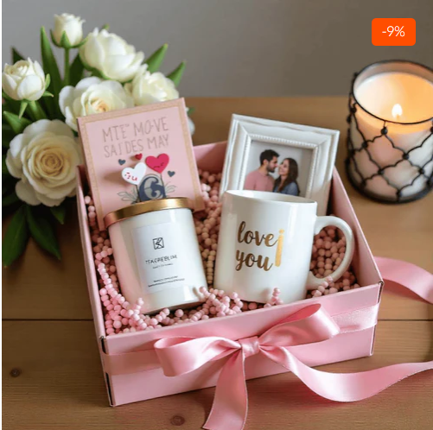

Anniversary Gifts: Celebrating Love Through the Years
Anniversaries mark the beautiful journey of togetherness, and finding the perfect anniversary gift for husband or anniversary gift for wife should be as special as your relationship. At Mematgo, we specialize in creating custom anniversary gifts that capture the essence of your unique bond.

1. Personalized Anniversary Gifts for Every Couple
Our personalized anniversary gifts are thoughtfully designed to reflect the depth of your emotions. From elegantly engraved photo frames to custom-made keepsakes, each piece is crafted with precision and care. When you choose anniversary gifts for couples from Mematgo, you're selecting more than just a product—you're creating a timeless treasure.
Popular Anniversary Gift Categories:
• Anniversary gift for husband: Personalized wallets, custom watches, engraved cufflinks, and photo collages
• Anniversary gift for wife: Customized jewelry boxes, personalized photo albums, engraved perfume bottles, and custom artwork
• Anniversary gifts for parents: Family tree frames, customized nameplates, photo cushions, and personalized wall art
• Mom dad anniversary gift: Couple photo frames, engraved plaques, customized mugs, and memory books
• Anniversary gifts for couples: Matching accessories, couple diaries, personalized home décor, and custom keychains

2. Anniversary Gifts for Parents: Honoring Their Legacy
Finding the perfect anniversary gifts for parents requires understanding their journey together. Our mom dad anniversary gift collection features timeless pieces that celebrate their enduring love. From customized photo frames showcasing family memories to elegant home décor items, each personalized anniversary gift is designed to make them feel cherished.
Why Choose Mematgo for Anniversary Gifts?
• Premium Quality Materials: We use only the finest materials for all our custom anniversary gifts
• Expert Craftsmanship: Every personalized anniversary gift is meticulously crafted by skilled artisans
• Customization Options: Unlimited personalization for anniversary gifts for couples
• Fast Delivery: Quick turnaround for all anniversary gift for husband and anniversary gift for wife orders
• Affordable Pricing: Competitive rates without compromising on quality

Wedding Gifts: Making Special Days Unforgettable
Weddings are magical celebrations of love, and the right wedding gifts for couples can make these moments even more memorable. Mematgo offers an exquisite collection of custom wedding gifts that blend tradition with contemporary elegance, making us the go-to choice for best wedding gifts in India.
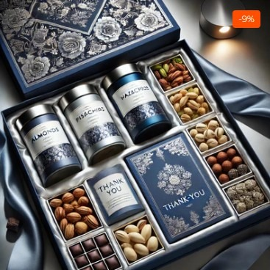

1. Custom Wedding Gifts That Stand Out
Our custom wedding gifts are designed to leave lasting impressions. Whether you're searching for a wedding gift for bride, wedding gift for best friend, or personalized wedding gifts for the newlyweds, our collection offers something extraordinary for every relationship. Each wedding gifts for girls item is carefully curated to match the joy of the occasion.
Exclusive Wedding Gift Collections:
• Wedding gifts for couples: Personalized couple frames, custom home décor, engraved serving sets, and matching accessories
• Wedding gift for bride: Customized jewelry boxes, personalized vanity sets, engraved accessories, and beauty organizers
• Wedding gift for best friend: Custom photo albums, personalized wall hangings, engraved keepsake boxes, and memory journals
• Wedding gifts for girls: Personalized cosmetic bags, custom diaries, engraved accessories, and decorative items
• Best wedding gifts: Premium quality hampers, luxury gift sets, custom artwork, and personalized home essentials

2. Personalized Wedding Gifts: Adding a Personal Touch
What makes our personalized wedding gifts truly special is the attention to detail. Every custom wedding gift can be tailored with names, dates, special messages, or meaningful quotes. This personalization transforms ordinary items into cherished mementos. Our best wedding gifts category includes everything from elegant home décor to practical everyday items, all customizable to reflect the couple's unique story.
Features of Our Wedding Gift Collection:
1. Diverse Range: Extensive selection of wedding gifts for couples and individual presents
2. Quality Assurance: All custom wedding gifts undergo strict quality checks
3. Unique Designs: Exclusive patterns and styles for personalized wedding gifts
4. Customization Freedom: Unlimited options for personalizing wedding gift for bride items
5. Premium Packaging: Elegant presentation for all best wedding gifts
6. Express Delivery: Timely delivery for wedding gift for best friend orders

Custom Wallets for Men: Style Meets Personalization
A wallet is more than just an accessory—it's a daily companion. Our collection of custom wallets for men combines functionality with personal expression. Each wallet for men with name is crafted from premium materials and can be customized to reflect individual style and preferences.
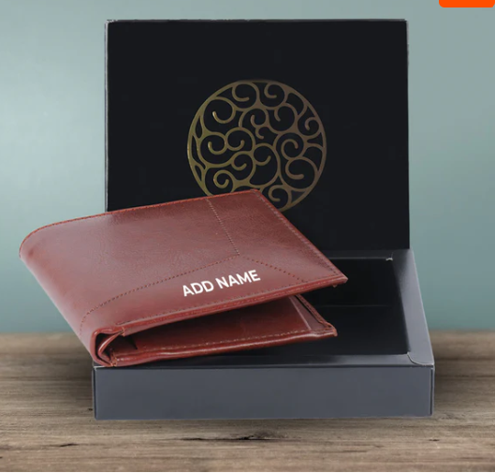

1. Personalized Wallets for Men: Quality and Craftsmanship
Our personalized wallets for men are manufactured using genuine leather and high-quality materials that ensure durability and elegance. Whether you're looking for a gift or treating yourself, our custom wallets for men offer the perfect blend of sophistication and practicality. Each wallet for men with name is precision-engraved to create a lasting impression.
Why Choose Mematgo's Custom Wallets:
• Premium Leather: All personalized wallets for men are crafted from genuine leather
• Perfect Personalization: Every wallet for men with name features precise engraving
• Multiple Styles: Diverse designs in our custom wallets for men collection
• Durability: Long-lasting quality in all personalized wallets for men
• Gift-Ready: Elegant packaging for custom wallets for men purchases
• Affordable Luxury: Competitive pricing for premium wallet for men with name products
Each personalized wallet for men in our collection features multiple card slots, currency compartments, and ID windows. The customization options for our custom wallets for men include name engraving, initials, special dates, or meaningful quotes. This makes every wallet for men with name a unique accessory that stands out.

Custom Couple Gifts: Celebrating Togetherness
Love deserves to be celebrated in unique ways, and our custom couple gifts are designed to do exactly that. From personalized couple gifts for special occasions to everyday tokens of affection, Mematgo offers a beautiful range of items that strengthen bonds and create memories.

1. Personalized Couple Gifts: Expressing Love Creatively
Our personalized couple gifts range from matching accessories to customized home décor items. Each piece in our custom couple gifts collection is designed to symbolize the unique connection between partners. Whether it's a first date anniversary or a milestone celebration, our gifts help you express what words sometimes cannot.
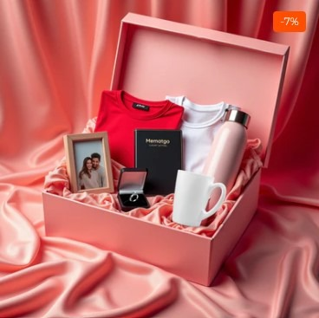
Popular Custom Couple Gifts:
• Matching Accessories: Coordinated items from our custom couple gifts collection
• Photo Frames: Customized frames perfect for personalized couple gifts
• Couple Mugs: Personalized drinkware from custom couple gifts range
• Wall Art: Custom designs ideal as personalized couple gifts
• Keychains: Matching sets in our custom couple gifts category
• Cushions: Photo cushions from the personalized couple gifts collection
Our custom couple gifts are perfect for various occasions including Valentine's Day, anniversaries, birthdays, or just because. Each personalized couple gift can be customized with photos, names, dates, or special messages, making them truly one-of-a-kind treasures.

Customized Diaries: Organizing Life with Style
In the digital age, there's something special about putting pen to paper. Our customized diary collection offers the perfect blend of functionality and personalization. Whether you need a customized diary with name for professional use or a diary and pen gift set for someone special, we have options that impress.
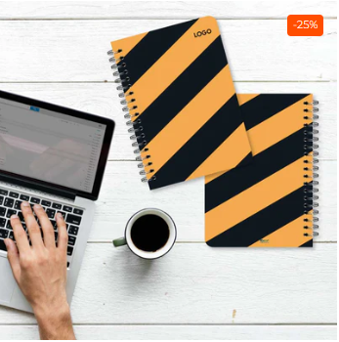

1. Customized Diary with Name: Personal and Professional
Each customized diary with name in our collection is crafted with attention to detail. From premium paper quality to elegant cover designs, our customized diary products cater to both personal journaling and professional note-taking. The addition of a name makes each customized diary with name feel truly personal.
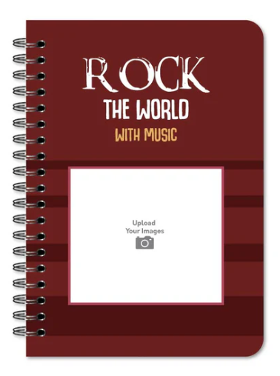

2. Diary and Pen Gift Sets: Complete Writing Solutions
Our diary and pen gift set combinations make perfect corporate gifts and personal presents. Each customized diary and pen set is carefully curated to ensure quality and coherence. The personalised diary and pen set options include various styles, from classic to contemporary, making them suitable for any recipient.
Diary Collection Features:
• Customized diary: Available in multiple sizes and formats
• Customized diary with name: Precision engraving or embossing on covers
• Customized diary and pen: Perfectly matched combinations
• Diary and pen gift set: Ready-to-gift packaging included
• Personalised diary and pen set: Corporate and personal gifting options
• Premium paper quality in all customized diary products
• Durable bindings for every customized diary with name
• Multiple color options in diary and pen gift set range
Our customized diary products serve multiple purposes. Students love the customized diary with name for academics, professionals prefer our diary and pen gift set for meetings and planning, while creative individuals enjoy the personalised diary and pen set for journaling and sketching. The versatility of our customized diary and pen combinations makes them ideal for any occasion.

The Mematgo Difference: Why We Stand Out
With countless options available online, what makes Mematgo special? It's our unwavering commitment to quality, personalization, and customer satisfaction. Whether you're ordering custom anniversary gifts, wedding gifts for couples, or personalized wallets for men, you'll experience the Mematgo difference at every step.

1. Quality That Speaks Volumes
Every product, from our personalized anniversary gifts to our custom couple gifts, undergoes rigorous quality checks. We source the finest materials for our custom wallets for men and ensure that each customized diary with name meets our high standards. This commitment to excellence has made us a trusted name in personalized wedding gifts and anniversary gifts for couples.

2. Unlimited Customization Options
Personalization is at the heart of everything we do. Whether you want a specific message on your anniversary gift for husband, a unique design for your wedding gift for bride, or custom engraving on your wallet for men with name, we make it happen. Our design team works closely with customers to create personalized couple gifts and mom dad anniversary gift items that exceed expectations.

3. Customer-Centric Approach
From the moment you browse our collection of anniversary gifts for parents to the delivery of your personalised diary and pen set, we prioritize your experience. Our customer service team is always ready to help you choose the perfect wedding gift for best friend or assist with customizing anniversary gifts for couples. This dedication has earned us thousands of satisfied customers across India.

Complete Gifting Guide: Choosing the Perfect Present
Selecting the right gift can be challenging. To help you navigate our extensive collection of custom anniversary gifts, personalized wedding gifts, and more, we've created this comprehensive gifting guide.

For Anniversary Celebrations:
When choosing anniversary gifts for couples, consider the milestone being celebrated. For first anniversaries, our custom couple gifts with photos from the wedding work beautifully. For milestone years, our personalized anniversary gifts with special engravings make lasting impressions. Parents appreciate our mom dad anniversary gift collection featuring family photos and meaningful messages.

For Wedding Occasions:
Wedding gifts for couples should be both practical and memorable. Our best wedding gifts include home décor items and personalized accessories. For the bride specifically, our wedding gift for bride collection offers elegant and feminine options. When selecting a wedding gift for best friend, consider items from our personalized couple gifts range that celebrate their unique story.

For Men's Gifts:
Our custom wallets for men make excellent gifts for any occasion. Each wallet for men with name adds a personal touch that shows thoughtfulness. The personalized wallets for men category includes various styles from formal to casual, ensuring you find the perfect match for the recipient's personality.

For Professional Gifting:
Corporate gifts require a balance of professionalism and personalization. Our diary and pen gift set options are perfect for client appreciation or employee recognition. The customized diary and pen combinations can be branded with company logos while maintaining elegance. Each personalised diary and pen set comes in premium packaging suitable for professional gifting.

Conclusion: Your Partner in Meaningful Gifting
At Mematgo, we understand that the perfect gift is more than just a product—it's an expression of love, appreciation, and thoughtfulness. Whether you're searching for custom anniversary gifts to celebrate years of togetherness, wedding gifts for couples to mark new beginnings, custom wallets for men to show appreciation, or customized diary products for practical elegance, we're here to help.
Our extensive collection of personalized anniversary gifts, personalized wedding gifts, personalized wallets for men, custom couple gifts, and diary and pen gift set options ensures you'll find something special for every occasion and every relationship.
From anniversary gift for husband to anniversary gift for wife, from wedding gift for bride to wedding gift for best friend, from wallet for men with name to personalised diary and pen set, we're committed to making your gifting experience memorable and meaningful.
Thank you for choosing Mematgo as your partner in celebrating life's special moments. Every custom anniversary gift, custom wedding gift, personalized wallet for men, and customized diary we create is a testament to our commitment to quality, personalization, and your satisfaction.

Get in Touch
Ready to order your perfect personalized anniversary gifts, custom wedding gifts, custom wallets for men, or customized diary products? Whether you need anniversary gifts for couples, wedding gifts for couples, personalized wallets for men, personalized couple gifts, or diary and pen gift set options, our team is ready to assist you in creating the perfect personalized gift.

📞 Phone: +91 9715714714
✉ Email: order@mematgo.com
🌐 Website: https://www.mematgo.com/

Thankyou

