lia, Canada, EU, GCC, New Zealand, UK & USA.Your order arrives without extra charges.


South Korean Won (KRW)

Kaftan Styling Guide: Essential Accessories That Complete the Look
February 11, 2026
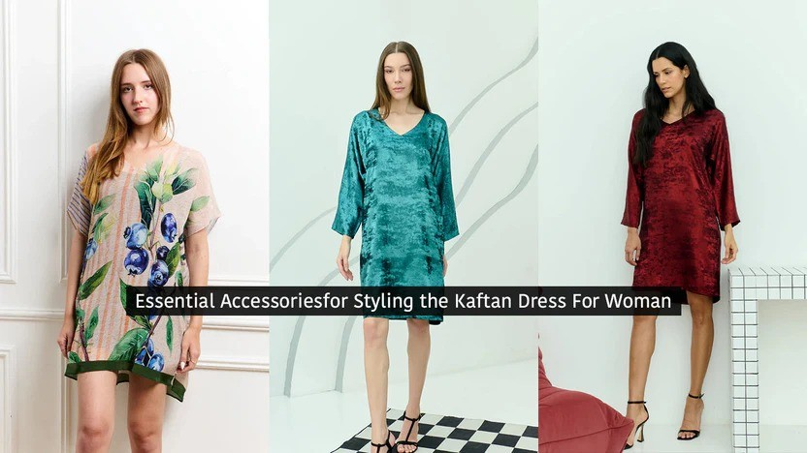

A kaftan is designed to feel easy.
But what completes the look is not the garment alone — it is how it is styled. The right accessories do not overpower a kaftan. They bring clarity and balance to it.
When chosen well, they make the outfit feel finished without making it feel heavy.
A kaftan is naturally ﬂuid, but sometimes a bit of definition helps.
A slim belt can introduce structure while keeping the overall look relaxed. Fabric ties feel softer and more casual, while chain belts work better for evenings or occasions.
The goal is not to change the silhouette, but to guide it slightly.

Kaftans work best with minimal jewellery.
Footwear changes how the kaftan feels.
Flat sandals keep it simple and relaxed
Wedges or espadrilles add height without losing comfort Heels shift the look towards evening or occasion wear
The bag should support the look, not compete with it.
Larger totes or soft bags work well for daytime and travel Crossbody styles add practicality for everyday wear
Smaller clutches or structured mini bags are better suited for evenings

Layering a kaftan is not always necessary, but when done right, it adds depth. The layer should feel effortless — almost like part of the kaftan itself.
Simple additions can complete the look: Sunglasses or hats for daytime Minimal hair accessories
Anklets or subtle finishing touches
One of the biggest strengths of a kaftan is versatility.
ﬂats, a relaxed bag, minimal jewellery a belt, structured accessories, clean styling heels, refined jewellery, a smaller bag
You can explore styles at — pieces that are made to be worn through the day, not just styled once and forgotten.

WELCOME TO DHARA SHETH
Our newsletter keeps you updated on all our news, collections and access to exclusive offers.
Email address
Subscribe

ABOUT US CONTACT US GALLERY BLOG DELIVERY POLICY RETURN AND REFUND POLICY PRIVACY POLICY TERMS & CONDITIONS SIZE GUIDE

© 2026 Dhara Sheth



Beach kaftan coverups UAE | Designer kimonos Dubai | Designer beach sarong UAE |
Spaghetti Strap Dresses | Designer dresses online Dubai | Long Kaftans UAE |
Mid-Length Kaftans UAE | Summer fashion sarongs Dubai | Printed luxury kaftan UAE |
Party wear kaftan Dubai | Summer fashion Dresses Dubai | sarong | kimono | shimmer kimono | maxi dresses | dhara sheth | long kimono | bird kimono | dubai dhara | plain kaftan dress | kaftan dress party wear | women's luxe sarongs | sequin kaftan dress | sarong dress | wordrobe | kaftan dress uae | stylish kimonos | women's luxe sarong | kaftan dress shops in dubai |
long sheer kaftan | short kaftans | kimono for women | luxury maxi dresses |
buy party wear kaftans | luxe women sarong | dubai maxi dress | women kimonos | short kimono |
kaftan uae | kimono uae | high-end maxi dresses dubai | Long Kaftans

