Best Online Slots with Low Minimum Bets
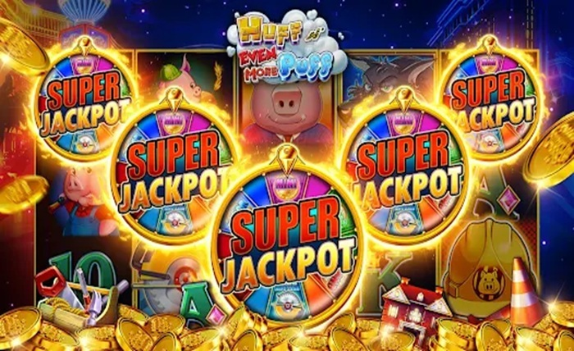
Online slots have grown to be certainly one of typically the most popular types of digital entertainment in recent years, attracting an incredible number of players from Slot Gacor the world. Unlike traditional slot machines within physical casinos, online slots are typically accessible through smartphones, tablets, and computers. This convenience allows players to savor a common games anytime and anywhere without the need to travel. The wide variety of themes, designs, and gameplay features makes online slots appealing to both beginners and experienced players, creating an energetic and engaging gaming environment.
Among the key reasons for the rapid growth of online slots could be the diversity of games available. From classic fruit machines to advanced video slots with cinematic graphics, there's something for everyone. Game developers continuously introduce new titles with unique storylines, bonus rounds, and innovative mechanics to help keep players entertained. This constant evolution ensures that online slots remain fresh and exciting, encouraging users to explore different Slot Gacor and discover new favorites.
Another important facet of online slots could be the role of technology, particularly Random Number Generators (RNGs). These systems ensure that every spin is totally random and fair, giving all players an equal chance of winning. The transparency and fairness of RNG-based systems have helped build trust among users, making online slots a trusted form of entertainment. Many reputable online casinos may also be regulated and audited by independent authorities, further ensuring a safe gaming experience.
Bonuses and promotions are a major attraction on the planet of online slots. Players can take advantage of welcome bonuses, free spins, cashback offers, and loyalty rewards. These incentives not just improve the gaming experience but offer additional opportunities to win without spending extra money. Understanding how to utilize these bonuses effectively can Slot Gacor improve a player's overall experience and extend their gameplay.
Despite being largely based on luck, you can find strategies that players can use to manage their gameplay more effectively. Bankroll management, choosing games with higher Go back to Player (RTP) percentages, and setting limits are some traditional practices that could Slot Gacor players enjoy online slots responsibly. While no strategy can guarantee consistent wins, adopting a disciplined approach can reduce risks and make the ability more enjoyable over time.
The visual and audio components of online slots also contribute greatly to their appeal. High-quality graphics, immersive soundtracks, and engaging animations create a captivating atmosphere that keeps players entertained. Many modern slot games feature themes inspired by movies, mythology, adventure, and fantasy, allowing players to feel section of a larger Slot Gacor while playing. This level of immersion is one of reasons why online slots stick out among other designs of online gaming.
Mobile gaming has further revolutionized the online slots industry. With many players now using smartphones, developers have optimized their games for mobile platforms Slot Gacor Which means players can enjoy seamless gameplay without compromising on quality or features. Mobile compatibility has significantly increased the reach of online slots, making them accessible to a broader audience across different regions.
In conclusion, online slots continue to dominate the internet gaming Slot Gacor due to their accessibility, variety, and engaging features. They offer a Unique mixture of entertainment, excitement, and potential rewards that interest a wide range of players. However, it is essential for individuals to approach online slots responsibly, viewing them as a questionnaire of entertainment rather than a guaranteed method to earn money. By understanding how these games work and setting personal limits, players can enjoy a safe and enjoyable gaming experience.

