NAGAGG: An Emerging Name in Online Gaming Entertainment

Introduction to NAGAGG
NAGAGG has gained attention among online gaming enthusiasts who are looking for a platform that combines entertainment, accessibility, and a variety of gaming experiences. As the online gaming industry continues to evolve, platforms like NAGAGG aim to provide users with a modern environment where they can enjoy different forms of digital entertainment from the comfort of their homes or while on the go.
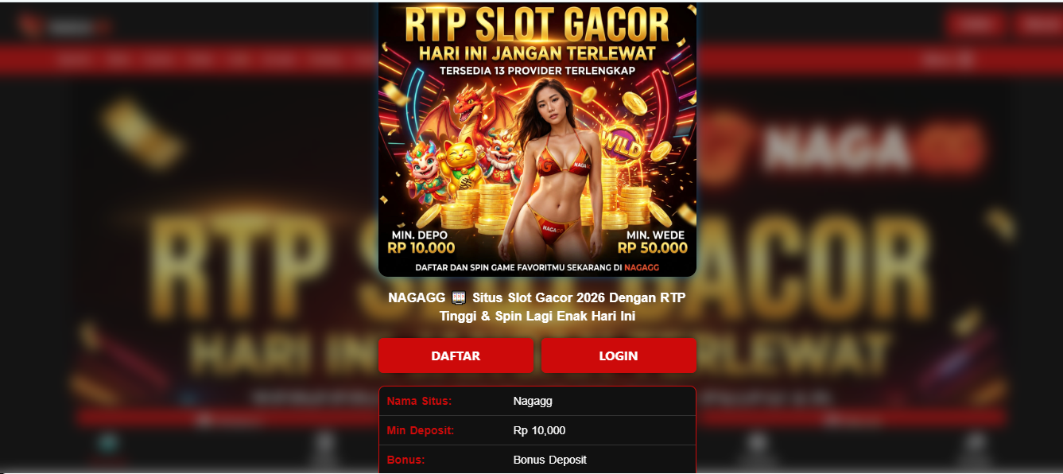

Diverse Gaming Options
One of the key attractions of NAGAGG is its diverse selection of games. Players often seek variety when choosing an online gaming platform, and NAGAGG strives to meet those expectations by offering multiple gaming categories. Whether users enjoy classic-style games, modern interactive experiences, or fast-paced entertainment, the platform provides options that cater to a broad range of interests and preferences.

User-Friendly Design
A well-organized platform can significantly improve the overall slot gacor experience, and NAGAGG focuses on creating an interface that is simple and intuitive. New users can easily navigate through the available features, while experienced players can quickly access their favorite sections. The streamlined design helps reduce confusion and allows users to focus more on enjoying the entertainment available on the platform.

Mobile Gaming Convenience
With the increasing popularity of smartphones and tablets, mobile compatibility has become an essential feature for online gaming platforms. NAGAGG is nagagg bonus to function smoothly across various devices, enabling players to access games anytime and anywhere. This flexibility ensures that users can stay connected to their favorite gaming activities without being restricted to a desktop computer.

Security and Reliability
Security is an important consideration for any online platform, and NAGAGG recognizes the value of protecting user information. The platform incorporates security measures intended to safeguard account data and support a safer gaming environment. By prioritizing security and reliability, NAGAGG works to build trust among its growing community of users.

Promotional Opportunities
Many online gaming enthusiasts appreciate platforms that offer promotional incentives, and NAGAGG is known for providing various reward opportunities. These promotions can enhance the overall gaming experience by giving players additional value and encouraging engagement. Special campaigns, bonuses, and loyalty rewards often contribute to a more exciting and rewarding environment.

Customer Support and Assistance
A strong customer support system is essential for maintaining user satisfaction. NAGAGG aims to provide helpful assistance for players who may have questions or encounter technical issues. Responsive support services help ensure that users receive timely guidance, making their overall experience more enjoyable and efficient.

The Future of NAGAGG
As online gaming continues to expand globally, NAGAGG is positioned to grow alongside industry trends and technological advancements. By focusing on game variety, user convenience, platform security, and customer satisfaction, NAGAGG continues to attract attention from players seeking a reliable and engaging online gaming destination. Its commitment to improving the user experience may contribute to its continued success in the competitive online gaming landscape.

