DragonSlot: A Complete Guide to an Exciting Online Slot Experience

Introduction
DragonSlot is a popular online slot gaming platform that attracts players with its exciting collection of slot games, rewarding bonus features, and user-friendly interface. Inspired by the legendary power and mystery of dragons, DragonSlot combines stunning graphics, immersive gameplay, and modern gaming technology to create an entertaining experience for both beginners and experienced players. Whether you enjoy classic fruit slots or feature-packed video slots, DragonSlot offers a wide variety of games Dragonslot suit every preference.
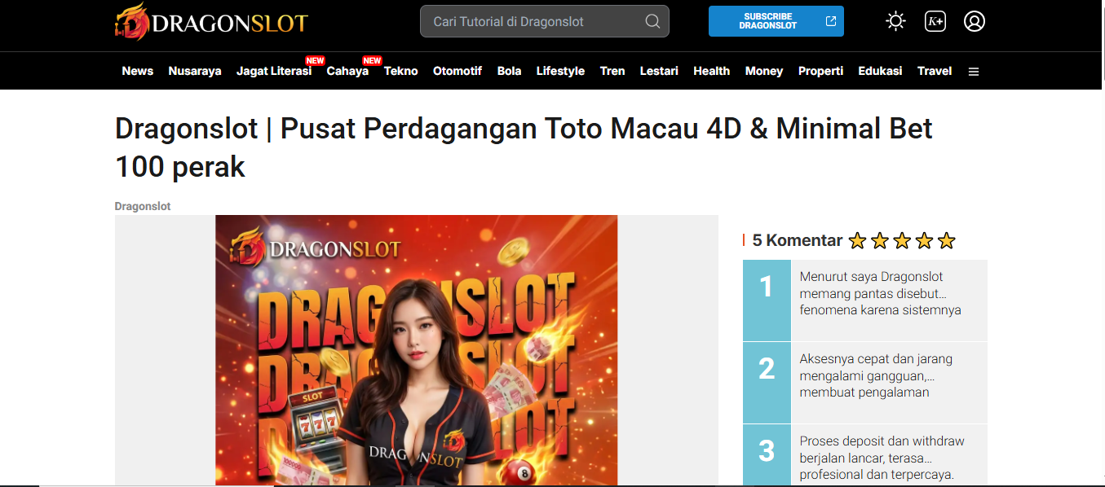

What Is DragonSlot?
DragonSlot is an online gaming platform that provides access to numerous slot machine games designed with engaging themes, high-quality visuals, and smooth gameplay. Many of its games feature dragons, ancient treasures, mythical creatures, and Dragonslot Login adventures that keep players entertained throughout every spin. The platform focuses on delivering a seamless gaming experience across desktop and mobile devices, allowing users to play whenever and wherever they choose.

Features That Make DragonSlot Popular
One of the main reasons DragonSlot continues to attract players is its impressive selection of gaming features. Players can enjoy fast-loading games, colorful animations, immersive sound effects, and exciting bonus rounds that increase the Dragonslot Daftar value of every session. Many games include free spins, multipliers, expanding wilds, scatter symbols, cascading reels, and jackpot opportunities. These features help create dynamic gameplay while offering players multiple ways to win during each game.

Wide Selection of Slot Games
DragonSlot offers an extensive library of online slot games with themes ranging from fantasy kingdoms and magical dragons to adventure, history, mythology, and classic casino favorites. The platform regularly updates its collection to Situs Dragonslot new titles and innovative mechanics that keep the experience fresh. Whether players prefer simple three-reel slots or advanced five-reel video slots with multiple paylines, DragonSlot provides options suitable for every playing style.

Bonuses and Promotional Offers
Many players choose DragonSlot because of its attractive promotions and bonus opportunities. New users may receive welcome bonuses, while existing players can benefit from reload bonuses, cashback offers, free spins, seasonal promotions, and loyalty rewards. These promotional campaigns allow players to enjoy additional Link Alternatif Dragonslot while maximizing the value of their deposits. Checking the latest promotional offers regularly can help players make the most of their gaming experience.

Mobile-Friendly Gaming Experience
Modern players expect flexibility, and DragonSlot delivers with excellent mobile compatibility. The platform is optimized for smartphones and tablets, allowing games to run smoothly without sacrificing graphics or performance. Whether using Android or iOS devices, players can enjoy their favorite slots with responsive controls and fast loading times. This convenience makes DragonSlot an excellent choice for users who prefer gaming on the go.

Safety, Security, and Fair Play
Security is an essential aspect of any online gaming platform, and DragonSlot prioritizes player protection through secure payment methods and encrypted Slot Online Gacor. Reputable gaming platforms use certified random number generators (RNGs) to ensure fair game outcomes, providing players with confidence that every spin is completely random. Responsible gaming features, account security measures, and reliable customer support further contribute to a trustworthy gaming environment.

Tips for Enjoying DragonSlot Responsibly
To get the best experience from DragonSlot, players should always set a gaming budget, understand the rules of each slot game, and choose games that match their preferred volatility and betting style. Taking advantage of bonuses, practicing bankroll management, and viewing online slots primarily as entertainment rather than a guaranteed source of income can help create a more enjoyable experience. Responsible gaming habits ensure that players maintain control while having fun.

Conclusion
DragonSlot offers an engaging online slot experience through its diverse game selection, attractive bonus features, mobile-friendly design, and immersive dragon-themed entertainment. With exciting gameplay, rewarding promotions, secure technology, and user-focused features, it continues to appeal to slot enthusiasts around the world. Whether you are new to online slots or an experienced player looking for fresh gaming adventures, DragonSlot provides a thrilling platform where entertainment and excitement come together.

